IMPLEMENTATION

The evolution of an advanced ADHD management system follows a very carefully defined and methodical process that starts with the essential data-collection phase, fundamental for the training of sophisticated machine learning models. In order to accomplish this, prior data are collected from all significant primary data sources, including primary schools for education and hospitals for health care. The raw information, then, will undergo a processing pipeline that involves the rigorous cleansing and filtering of irrelevant parameters, allowing the retention of data only relevant for training the machine learning model. At this stage, the data chosen will also undergo standardization processes to ensure conformity and a very high degree of quality. Afterwards, this cleansed and standardized data is going to be encrypted and stored in a database, focusing greatly on data security and privacy, bearing in mind the sensitive health information regarding children.

The fundamental interest driving the machine learning model develops into the offering of personalized and efficacious support for children with ADHD. It finds this realization through a synergy of real-time monitoring, advanced predictive analytics, and dynamic intervention strategies. This will induce continued follow-up with the associated personalized recommendations, which will instantly respond to the current needs of the child involved. The system is built upon historical data pertaining to children with ADHD and is expected to predict future challenges that a child might face and the corresponding preventive mechanisms called in to counteract those challenges. This capacity places valuable insight into prospective future impacts into the hands of teachers and caregivers, hence allowing timely and targeted intervention to stop those challenges from ever having a negative effect on the child.

To facilitate the monitoring of the child's progress and the effectiveness of the strategies put in place, an integrated monitoring dashboard will be built. This enables a clear and intuitive interface to track a child's progress over time and to use this information to assess whether the predicted prevention mechanisms are making a positive difference.

Before the beginning of model training, the prepared dataset will be passed through very exhaustive feature engineering processes geared toward identifying and extracting those features that would most significantly contribute to the predictive accuracy of machine-learning models. As a result, the processed dataset will be used to train different types of machine-learning models: Random Forest, Support Vector Machine, Logistic Regression, and Neural Networks. Each of these models will undergo the most rigorous validation and verification processes in order to know its viability for the prediction task. Each respective model shall be evaluated on a comparative basis using common performance metrics such as accuracy, precision, recall, and F1 score. The model with the highest accuracy shall be chosen as the best model for predicting the future challenges and putting into place prevention mechanisms for children with ADHD.

Once the best model is selected and trained, it is going to save all resulting predictions and mechanism recommendations in a secure database. This monitoring dashboard will then be used to track the child's progress against these interventions. This feedback loop means that there will be a continuous monitoring of the efficacy of predictions and prevention strategies implemented, and adjustments could be made whenever necessary.

In terms of the long-term upkeep, flexibility, and reproducibility of the model developed, the latter shall be endowed with an enforcement version control system, like GitHub. This allows updating, integration with other system components, and easy reproduction of the model at later dates for needs and improvements.

The selected model will, under version-control, be integrated into the web application to bring alive the robust predictive capabilities. The React frontend of the ADHD child prediction system serves an intuitive and responsive interface that allows seamless interaction for healthcare professionals, caregivers, and researchers with the machine learning models in the backend. The frontend is built with advanced React capabilities such as functional components and hooks," focuses on performance without compromising clarity or ease-of-use.

The Node.js backend of the ADHD child prediction platform is an important linking point between the React frontend and the machine learning models in Python. The backend has been constructed by using the Express.js framework to process the HTTP requests in an efficient way, so it also secures user-input data and makes scalable communication possible with their prediction engine. When a user submits a form in the React frontend with the child's most relevant features, that is behavioral, academic, and medical, it is sent to the Node.js backend through the considered REST API endpoints. The backend then carries out input validation and sanitization on data received to ensure that they are intact and protected against common security vulnerabilities like injection attacks or malformed requests. Considering the control measures that have been laid down for the backend API requests with a view to ensuring data integrity and to inhibit malicious inputs, every effort is made to reduce, to the maximum extent possible, the response time of the API requests in order to enhance user experience. Additionally, KPIs which give information about API throughput and average request duration are also monitored. Checks are implemented in assessing the error rate of requests, total requests accepted, and count of successful requests versus unsuccessful requests. The backend is designed to sustain interfacing with a trained ML model for data exchanges and provide instantaneous prediction results. Also, interfacing between backend and frontend is very meticulously managed to keep the downtime at a minimum and achieve low response times all the time so that the application feels fast and responsive. By taking these various aspects of backend API management and system integration into account, one can ensure a high-performance, reliable, and user-friendly ADHD Management System.

The backend then sends the validated information to the trained machine learning model. This backend receives two predictions from the machine learning model, the possible Future Challenge which the child might face (for example, academic, social, or attention problems), and a customized Prevention Mechanism that will address a particular profile of that child such as behavioral therapy, structured learning routines, or parent training. These predictions from the highly accurate models through method applied such as logistic regression with hyper-parameter tuning and class balancing through SMOTE are shown on the frontend through well-organized and aesthetically pleasing components as cards and charts.

The monitoring dashboard provides full insights into all aspects regarding a particular child, including the previous predictions, any mechanism followed, how much engaged the child has been in the given predictions, and how he has performed overall. Such a centralized dashboard is very helpful for teachers and caregivers in having a better understanding of the individual child's journey in counteracting the effects of ADHD.

The application is designed to realize all richness of usefulness and user experience through providing results from interactions immediately. The whole application will be containerized with Docker, a seamless portability and adaptability for diverse deployment environments. This creates an isolated and consistent environment and hence smooth applications run, irrespective of the underlying infrastructure.

The application would then be deployed onto Kubernetes to ensure high availability and reliable robustness after being containerized. Because of its self-healing ability, Kubernetes guarantees that the desired amount of application instances, called pods, will operate perpetually, thereby forbidding any downtime due to unforeseen events.

It then provides functionalities of applications that can be accessed to the users through a well-defined API, through clean and consistent interfaces for interaction. The application's functions have been strategically levered into Docker containerization and Kubernetes deployment for highly scalable and reliable performance of the application in various workloads. This very approach renders the system-of-system at ADHD intervention management robust, efficient, and largescale in nature, leveraging the best of machine learning and cloud computing technologies.

RESULTS

This research component has successfully developed thus far an advanced machine learning system intended to deal with the challenges confronting children with ADHD. At its core, this system uses random forest models that have been carefully optimized through grid search methods to make accurate predictions of troubles that may arise in the future. In order to ensure robust and reliable prediction performance, several aspects of preprocessing were also incorporated in the research, especially SMOTE (Synthetic Minority Over-sampling Technique) to balance imbalanced datasets and label encoding to transform categorical data into the machine-readable format. The entire system is modeled through an end-to-end pipeline covering the whole spectrum from thorough data cleaning, strategic model selection, and training and evaluation to smooth deployment. The pipeline was implemented in Python for the machine-learning components, Node.js for the backend and server-side logic, while React took care of the frontend and end-user interaction, making it accessible and practical for teachers and caregivers, and possibly the children as well.

The findings of this research highlighted a significant and fairly established correlation between certain behavioral and academic inputs and their predicted outcomes for children with ADHD; this implies that the system can relate meaningful patterns in the data. Those identified patterns and summary progress charts are shown in monitoring dashboard that made for teachers and caregivers to get an idea of progress of articular child. Monitoring dashboard will provide all necessary details to track progress of child whether they are going on provided instructions correctly and made progress to avoid from ADHD or they’re not getting any progress from provided instructions and may be in critical level of ADHD in future. From identifying these scenarios easily from dashboard like this and making predictions and recommendations will help significantly to get children rid from ADHD. While the system performed considerably well in the current dataset, the authors saw the importance of strengthening the dataset with a wider variety of longitudinal data. This would greatly reinforce the generalizability and clinical relevance of the system, ensuring that its applicability is effective even for a wider range of children with ADHD. Hence, the project laid a good base for further development, such as the implementation of real-time monitoring using wearable devices for the purpose of dynamic behavioral data collection, the development of a multi-class risk factor analysis framework aimed at characterizing other possible challenges, and the establishment of a personalized learning recommendation engine containing strengths and weaknesses tailored toward individual needs. In conclusion, this research wishes to substantially improve the educational and emotional welfare of children with ADHD through timely personalized data-driven support.

**Model Training**

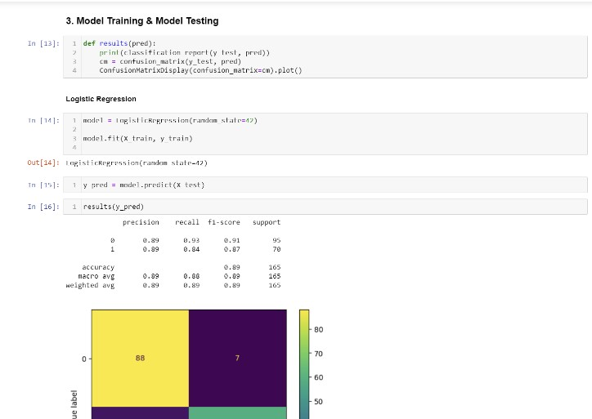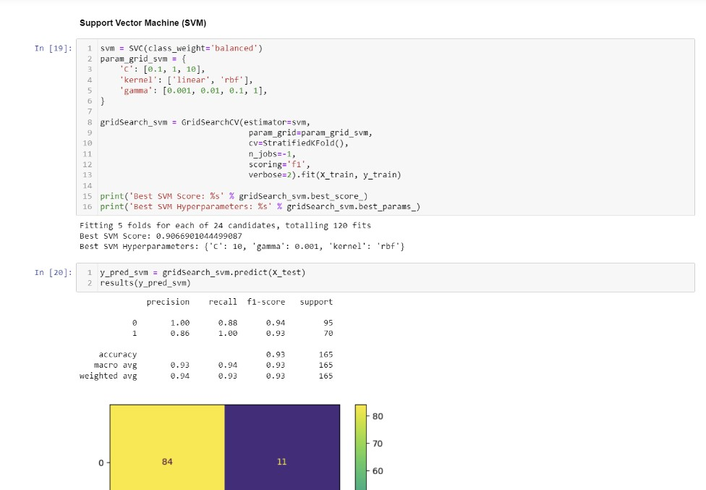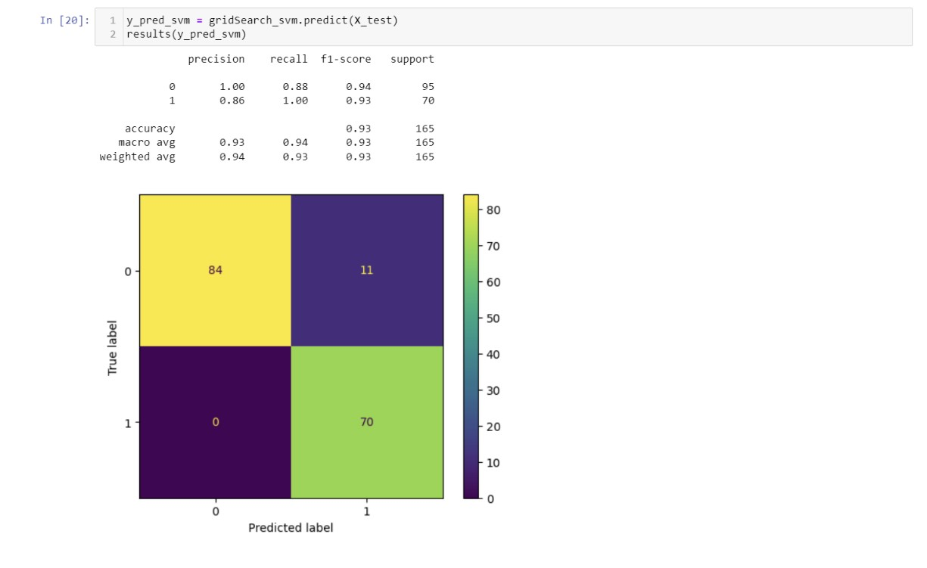

**Backend Test**